Patient Health Data

Name: Ms. Abby752 Beatty507

ID: 8f789d0b-3145-4cf2-8504-13159edaa747

This document contains graphs detailing changes in the patients vital signs over time

**Body Weight over time**

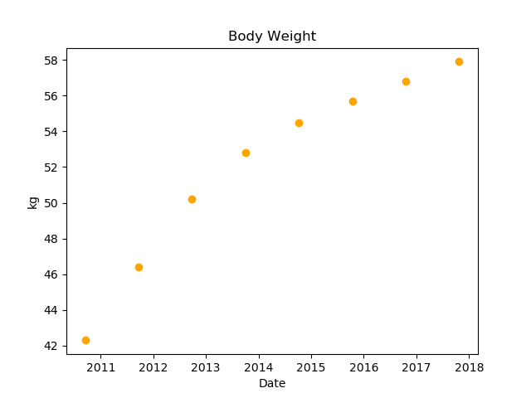

**Heart rate over time**

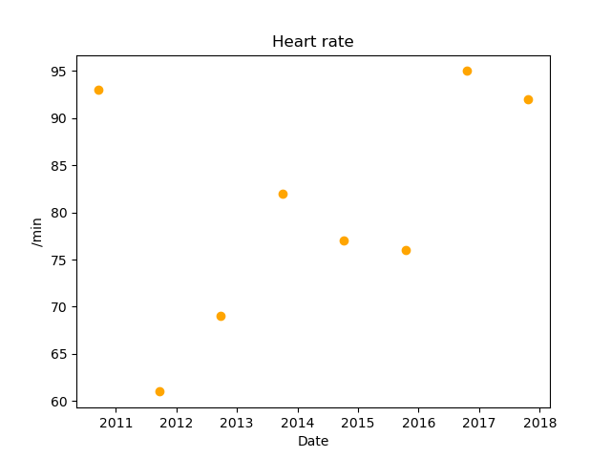

**Respiratory rate over time**

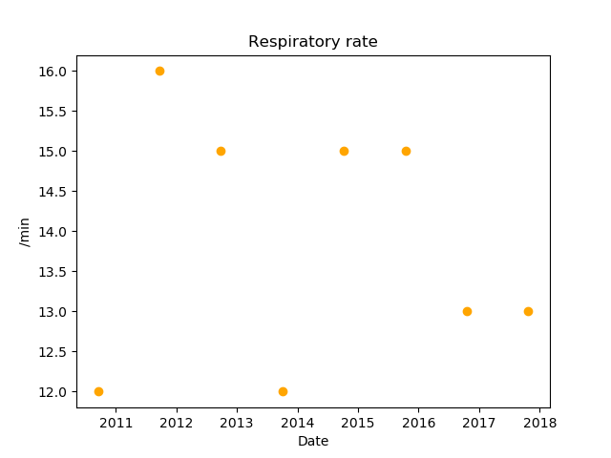

**Body Mass Index over time**

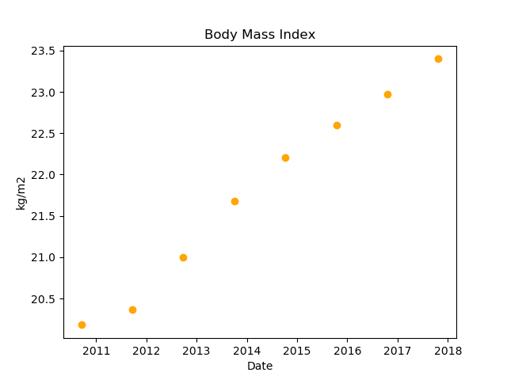

**Diastolic Blood Pressure over time**

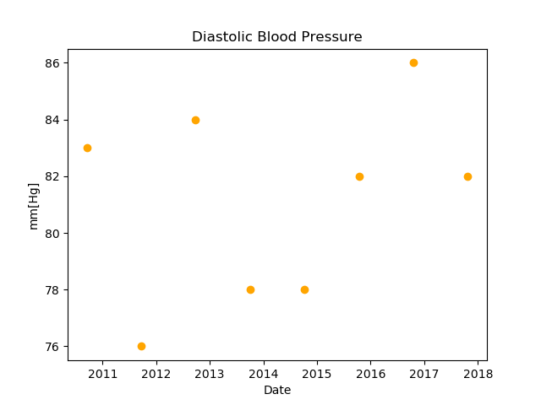

**Systolic Blood Pressure over time**

